
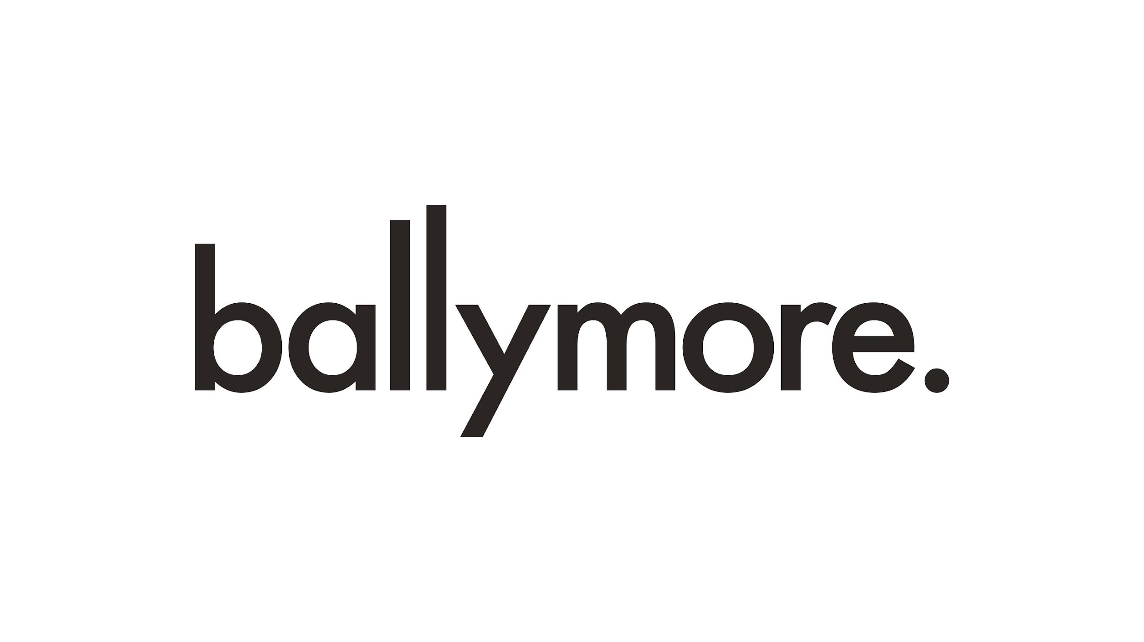



Competition
Open Call
More Edgware, Less Anywhere

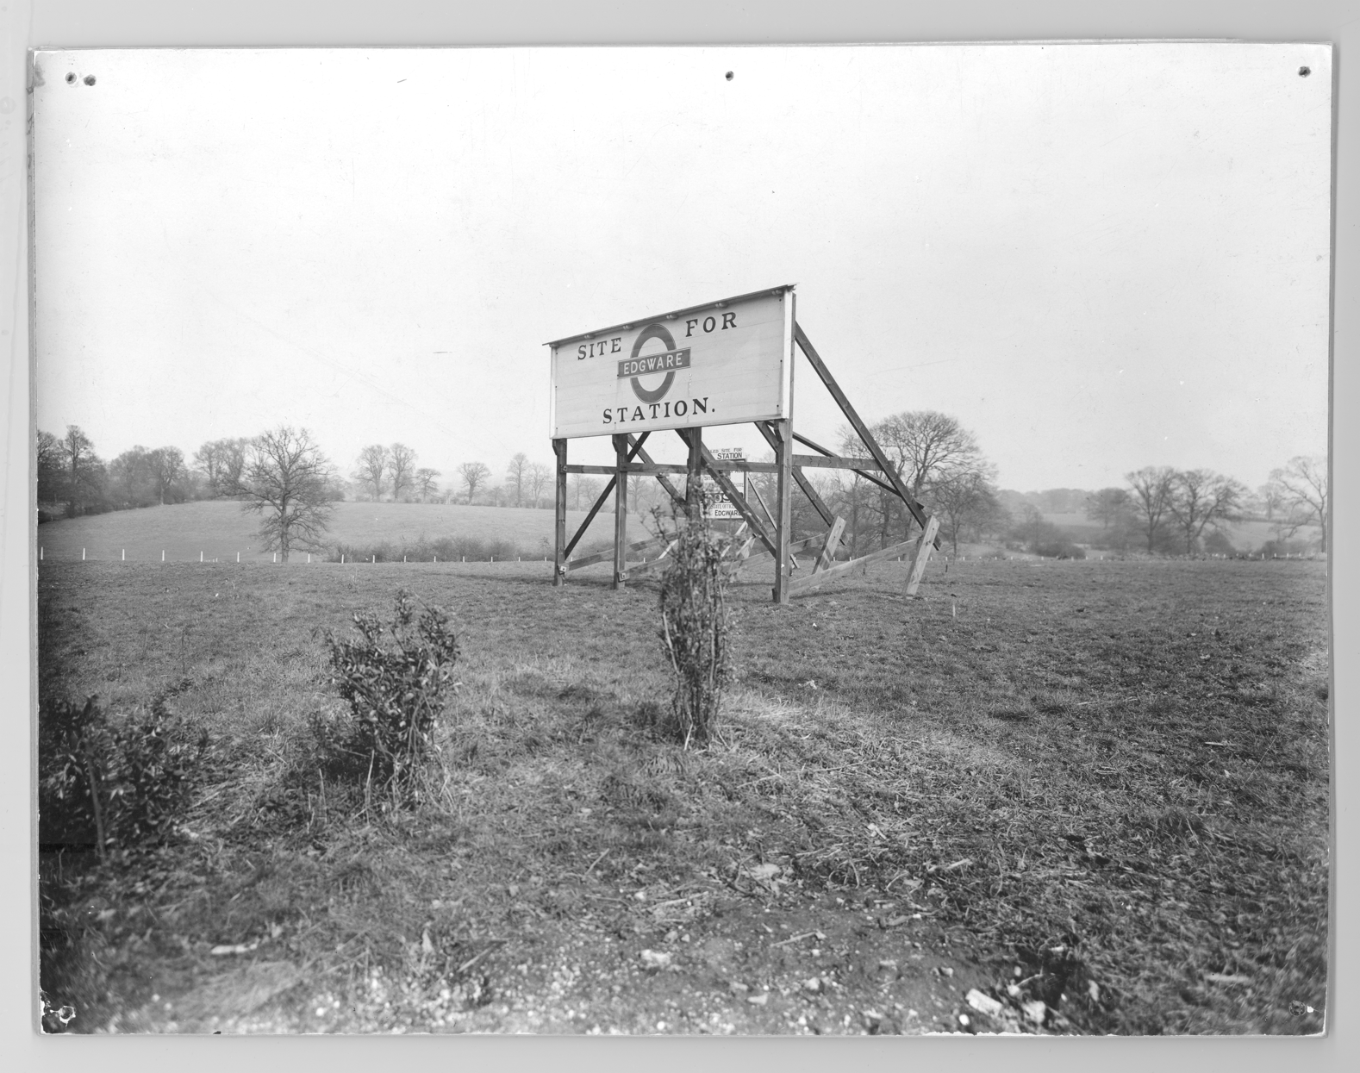

1
The commission

Barnet Council, in partnership with Ballymore, TfL and the London Festival of Architecture (LFA) is inviting emerging architects, landscape architects and designers to develop and submit a proposal for a new public realm intervention that will test ideas for ‘re-greening’ Edgware town centre and can help inform long term improvements to the area.

One-hundred years ago, Edgware station stood in a field, surrounded by green spaces and open countryside. Over the subsequent century, as the town centre has grown, the access routes to Edgware’s green spaces have become obscured. This competition invites designers to propose creative solutions for improving the visibility and permeability of Edgware’s green spaces from Station Road, as well as re-introducing greening on the high-street.
This is great opportunity to inform and build on projects already underway to tackle some of the challenges faced in the town centre and to make an early-stage contribution to what will be one of the biggest growth and regeneration projects in London.
A winning team will be confirmed in late March and awarded £46,000 + VAT (which includes a £6,000 design fee) to develop a fully costed, feasible design that can be delivered during June 2023. The delivered scheme will remain in-situ for 28 days, after which the intervention will be re-homed at an appropriate location.

2
Context

Edgware is located in the northwest of the London Borough of Barnet and is one of 30 town centres in the borough. It is the borough’s largest town centre and has been designated as a Main Town Centre by the borough and a Metropolitan Centre by the GLA. Edgware has evolved from a small market town into a major town centre and a well-known suburban hub of North London. The town centre also extends into a small part of the London Borough of Harrow, across the A5. The town centre encompasses several retail parades and streets, with the majority of commercial activity focussed around Station Road.

In 2021, Barnet Council adopted the Edgware Growth Area SPD. The SPD supports comprehensive redevelopment of key sites to reflect Edgware’s status as a major town centre, reinforce the role of the high street, provide new public spaces and make the street environment more attractive. The environment for pedestrians and cyclists will be improved, providing better options for more sustainable transport and safe and active movement. The town centre will also provide opportunities for new high-quality homes, including affordable housing.

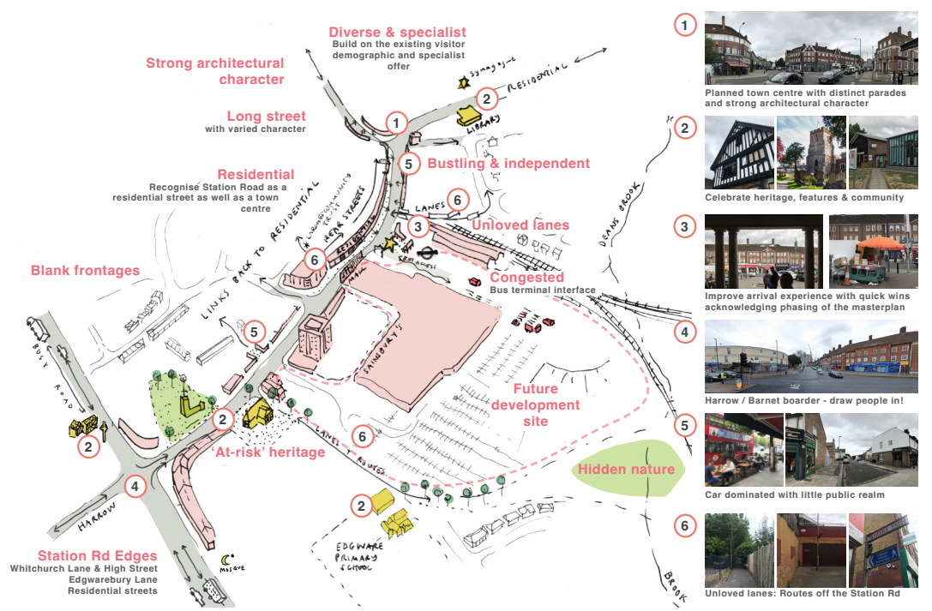

In July 2020, developer Ballymore acquired the Broadwalk Shopping Centre. The 7.5 ha site lies at the heart of Edgware Town Centre and, along with the Underground Station, platforms and tracks, and Edgware Bus Station/bus standing, is identified in the SPD as a major strategic development opportunity. Subsequently, Ballymore entered into a joint venture partnership with Transport for London, in order to bring forward comprehensive redevelopment of their combined site, in line with the vision and objectives set out in the SPD. The scheme is in pre-planning with an application currently due for submission Spring 2023.

As identified within the Barnet Growth Strategy 2030, the council has an ambitious programme of town centre investment to create thriving town centres that people want to live, work and spend time in. To achieve this commitment; the council is taking a proactive approach to help nurture them and celebrate their unique character through supporting them to become more attractive, healthier, greener, accessible, and well-connected places for all.

In alignment with this, the council also recently adopted the Barnet Long Term Transport Strategy which identifies a key aim for the council to improve walking and cycling infrastructure within the borough in order to improve the appeal and use of more active modes of transport to access our local town centres. The strategy identifies the need for high-quality public realm and highways to be designed to improve Barnet’s town centres as accessible destinations where our residents want to dwell and spend time.

Barnet’s new administration has re-affirmed the commitment to town centres, emphasising the role of local communities and businesses in leading regeneration and the need to place sustainability at the heart of town centre recovery. This temporary intervention for the London Festival of Architecture will be an exploratory project, testing out some of the long term ambitious for the area’s improvement which will be used to inform the wider work.

In addition, the scheme will be delivered in parallel with the following complimentary work streams being commissioned as part of a programme of centenary celebrations for Edgware Town Centre:
- Curation of a mural at a significant location along Station Road, likely on the former Argos unit, adjacent to the Station;
- A shopfront windows display initiative, delivered in partnership with local businesses;
- Community and celebratory events across the town centre, delivered in partnership with various stakeholders and organisations, including the Edgware Town Team

Applicants are welcomed to take the above into consideration when devising their proposals.

3
Site
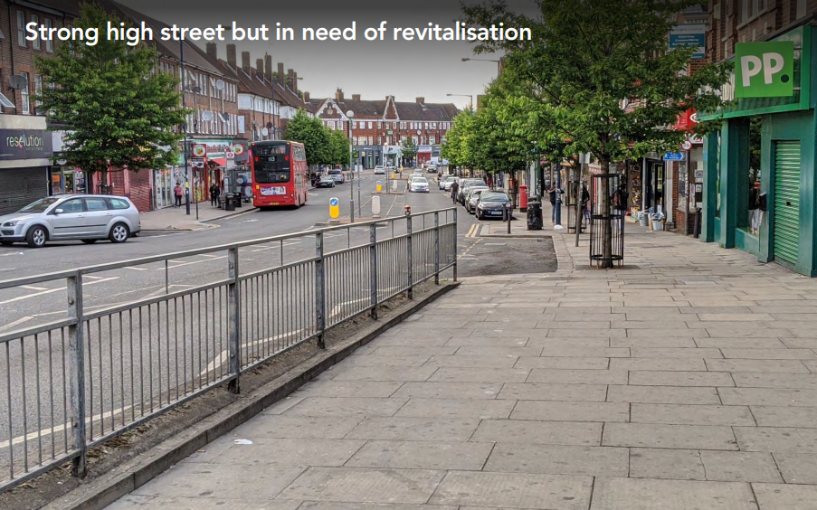
Station Road, Edgware

The available site(s) for the design intervention should be located along Station Road – boundaries indicated below. There are multiple possible locations for where the intervention could be implemented along the road, which are open for applicants to review and suggest at Stage 2 of the competition.

Potential sites sit on Barnet Highways land, however this does not prohibit ideas that span beyond these areas if they continue to meet the objectives of the brief and are mindful of the operations of the road.

More detailed information will be shared with shortlisted applicants, once selected.

4
Design Requirements

The applicant should provide a creative design solution for a site-specific public realm intervention that introduces new greening in the town centre while improving the visibility and permeability of Edgware’s existing green spaces, drawing on the place’s historic roots and improving the experience for residents and visitors.

The key objectives of the project are to deliver a design that:

- Celebrates the character and history of Edgware (see Edgware Not Anywhere cultural report appended)
- Introduces planting and greenery into Station Road, in a way that integrates successfully with the bustling high-street
- Incorporates wayfinding elements, signposting local green spaces accessible from Edgware. This scheme could focus on and encourage green/active travel
- Relates to and takes advantage of opportunities presented by the various projects happening in the area
- Explore this year’s LFA theme of ‘In Common’ and how it relates to this project
- Enables people to have more fun

The scheme could also explore:

- Provision of urban furniture such as cycle-parking or seating
- Inclusion of sound installations as a different medium to improve the immediate surrounding and encourage dwell time

5
Further guidance

- Environmental sustainability: The intervention should consider sustainability at every stage, from design through to delivery and decommission.
- Budget: The budget will be managed by the entrant. There is no restriction on how the budget should be divided between various aspects of the proposal.
- Materials: You can use salvaged materials or seek in-kind materials sponsorship to reduce expenses. We would encourage sustainable materials and disposal/recycle/after life need to be considered.
- Design: The intervention should be robust enough to withstand all weather conditions and potential damage, as well as to be used by multiple people simultaneously.
- Health & safety: The installation should be accessible, safe and secure for members of the public to interact with. The drawings will be checked by a Barnet engineer who will also carry out a risk assessment to ensure the project is safe for public use. Interventions should not block fire hydrants, fire exits, utility covers, street signage, or any other emergency access
- Durability: You should consider the longevity and appearance of your design according to its planned timeframe, to ensure that no maintenance is required during this period. Subject to durability, parts or all of your intervention may be able to be in place for longer than the festival timeframe and be used as part of other ‘events’.
- Maintenance: Design should also require minimum maintenance.

6
Budget

The total budget available for delivery of this project is circa £46,000+ VAT, including the cost of implementation - materials and any necessary licenses or other capital costs – and de-installation including final rehoming.

The winning team will be responsible for leading on the fabrication, installation and deinstallation of the design, whilst working closely with Barnet internal teams to facilitate the installation.

The £46,000 + VAT budget outlined includes a maximum £6,000 designer fee to cover on-going design fees and other costs required to deliver the concept.

The applicant should undertake the following tasks:
- Provide a feasible and on-budget design intervention that is robust enough to be in the public realm for its duration
- Consult with key stakeholders, including Barnet Council, local residents and businesses, and community and cultural organisations
- Project management and delivery of the winning design, incl. deinstall

7
Submissions requirements

This competition has a two stages submission.

This first stage submission should include:
- Full name and contact details including postal address, contact number and email of project lead.
- Brief biographies of all the project team.
- A 200-word description about your practice along with any relevant technical experience acquired through previous projects.
- A selection of relevant previous work, including images.
- A short paragraph of max. 300 words on why you are interested in being involved in the project. Please include some thoughts about your vision including any initial written reactions you may have to the brief.
- No design work is required for the first stage.

These submissions will be shortlisted by the judging panel. Up to 6 shortlisted practices will then be invited to develop a design concept based on the information laid out in this open call and will be awarded an honorarium of £750 Inc. VAT each. The work required for the second phase of the project will be reflective of the honorarium sum.

At shortlisting, the second stage submission should include:
- 2 x A2 boards in portrait format explaining your proposal.
- PowerPoint presentation for the purposes of judging.
- The submission should but is not limited to including hand or computer drawn 3D design visualisation, key construction details drawn to scale, with key dimensions noted, an outline all materials, budget, maintenance plan and fabrication process.

Submission information
For any questions about the competition or submission process, please email: info@londonfestivalofarchitecture.org

8
Eligibility

The competition is open to architects, landscape architects, designers and artists. Collaborations are welcomed; however, the project must be actively led by a named emerging architect, engineer or designer.

Applicants need to fulfil at least two of the following criteria to be eligible for this competition:
- being no more than seven years post graduate, from your most recent qualification
- being under 40
- set up your practice / collaboration in the past three years

The judges encourage entries from, or collaborations with groups who are underrepresented in architecture.

9
Deadline and submission details

- Deadline for first submission is Midday, 22nd February Submissions received after time this will not be considered.
- For competition enquires please contact: info@londonfestivalofarchitecture.org
- To send your expression of interest in a PDF format go here.
- The PDF should be no more than 5MB and 10 A4 pages.
- You will receive an email confirming the receipt of your submission.

10
Schedule outline

Submissions open: 26th January
Submissions closed: 22nd February
Successful shortlisted teams notified: 3rd March
Round 2 submission deadline: 22nd March, midday (12pm)
Final judging / interviews: w/c 27th March
Winner notified: 31st March

11
Judging panel

The judging panel will include:

Lucy Devereux, Barnet Council, Town Centre Investment Manager
Synthia Griffin, Barnet Council, Creative Economy Officer
Lucy Atlee, TfL, Quality & Design Manager
Ballymore representative
Local Community representative

Rosa Rogina, London Festival of Architecture, Director – Chair

More judges to be announced shortly.

12
Judging criteria

Round 1 Judging Criteria
- Practice/Team profile - 40% Does the team have skilled professionals for delivering the proposal in line with eligibility outlined in the Open Call? Does the team have a diverse set of skills and experience? Are the previous work experiences and/or their work methodologies and wider design aspirations relevant to the competition?
- Initial vision - 30%: Does the proposal's initial written reflection to the brief suggest innovation, surprise and creativity? Does it explore a new and original way to use and engage with the area?
- Feasibility - 30%: Does it propose an approach which seems feasible and deliverable within the budget and set timeframe?

Round 2 Judging Criteria
- Overall design – 25%
- Costs – 20%
- Approach to environment and sustainability – 15%
- Longevity and implications for maintenance – 15%
- Contextual design and local relevance – 15%

13
Further information

- Submissions will be judged on originality, demonstration of creativity, relevance to the brief as well as feasibility and how the proposal works in the context of the site.
- To process entries to this competition we will share your application and any associated personal data provided on the application with our jury and competition partners.
- All applicants will be notified of the outcome of their application, but due to the volume of submissions we may not be able to provide feedback to entrants individually.
- The ownership of Copyright of the design will be in accordance with the Copyright, Designs and Patents Act 1988, that is Copyright rests with the author of the submitted design.
- All designs remain the intellectual property of the designer however the winning design will itself when built will be the property of the landowners.
- Please bear in mind the project requires a fast turn around and may have peak moments when your practice will need to dedicate sufficient staff to deliver the project on time, to budget and to the high standard expected by all stakeholders.
- If selected, your practice/collaboration will need to organise Public Liability (of £5million). If your practice/collaboration does not currently hold the requested level of insurances, you can use part of the project budget for uplifting the existing or getting a new insurance policy.
- Significant efforts are made by all stakeholders of the project to ensure wide media coverage.
- LFA reserve the right to use images from the submissions for promotional purposes in press, social media and publications. All endeavours will be made to ensure accurate accreditation.

14
Useful links

London Festival of Architecture:
www.londonfestivalofarchitecture.org

Edgware Town Centre Partnership Steering Group
Welcome | Edgware - Your High Street (edgwareyourhighstreet.com)

Ballymore & TfL Consultation Website for The Broadwalk Shopping Centre and Bus Garage regeneration
Have Your Say Today - Broadwalk Centre And Edgware Bus Station - Commonplace

15
The Story of Edgware in Images

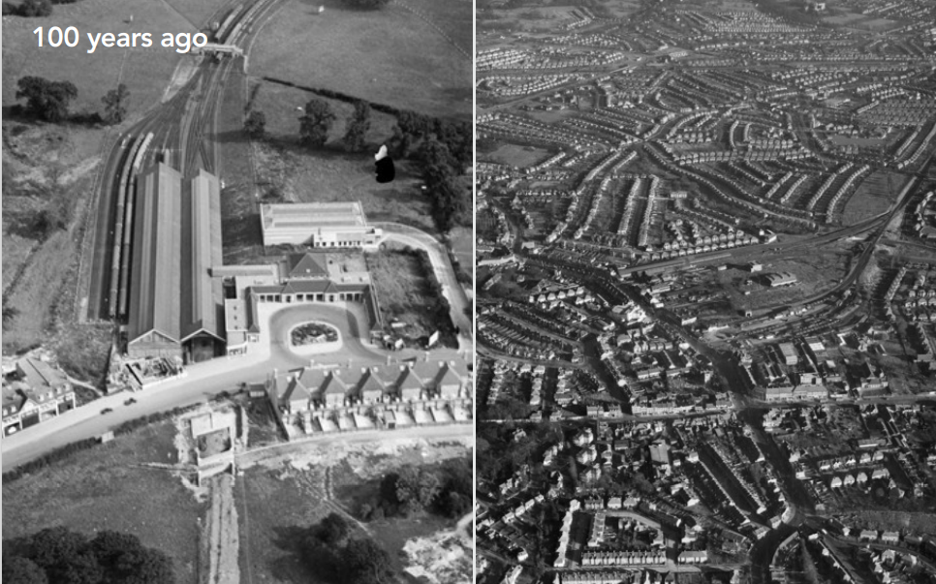
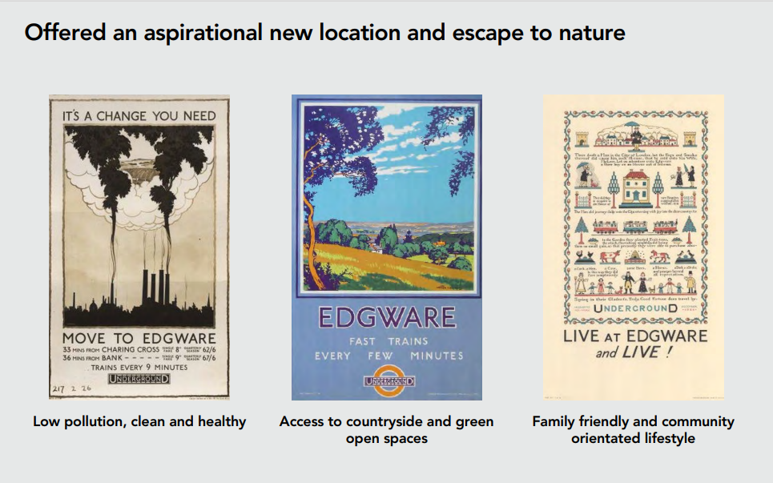
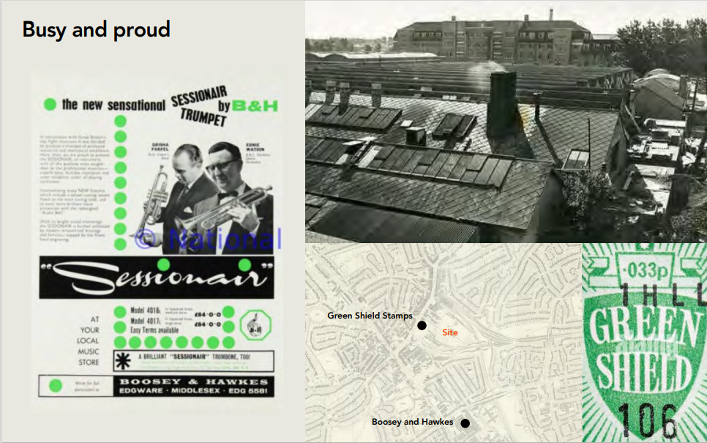
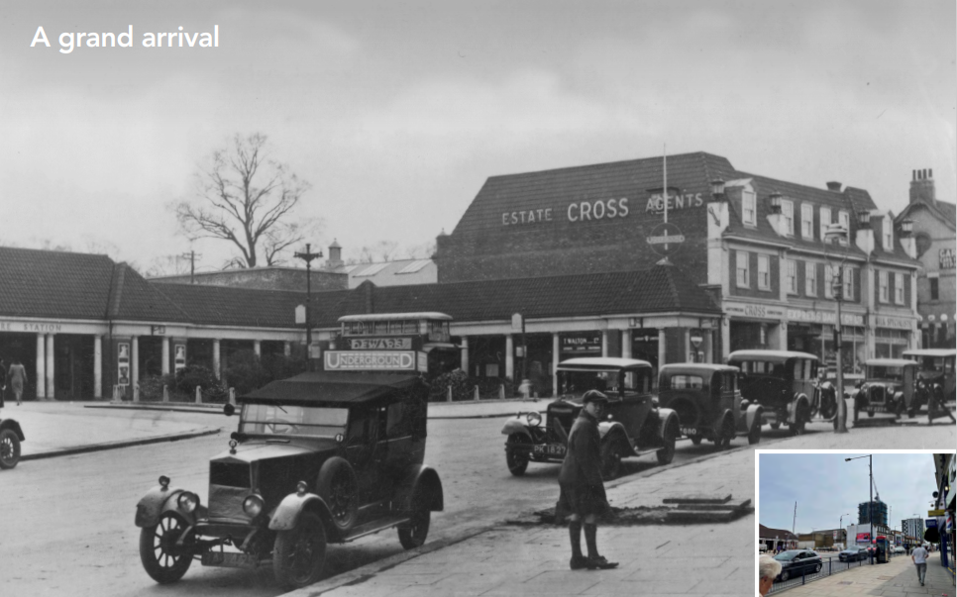
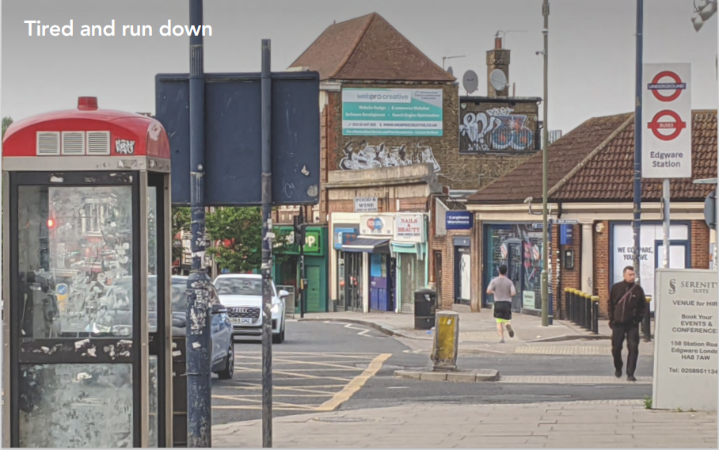
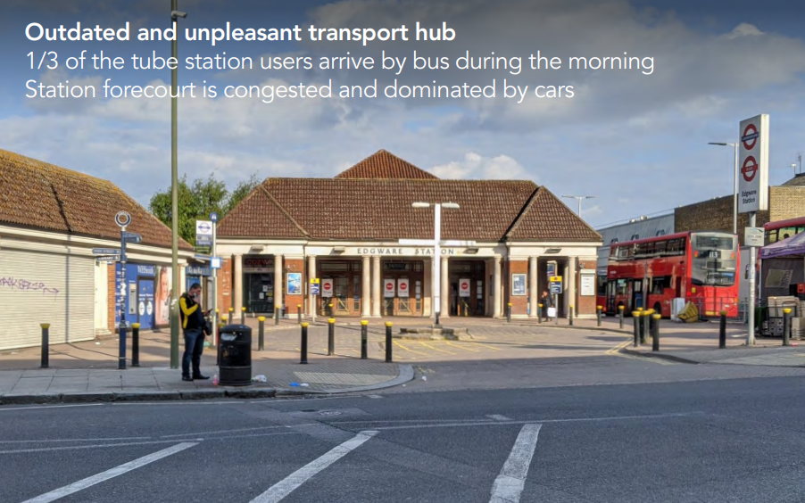
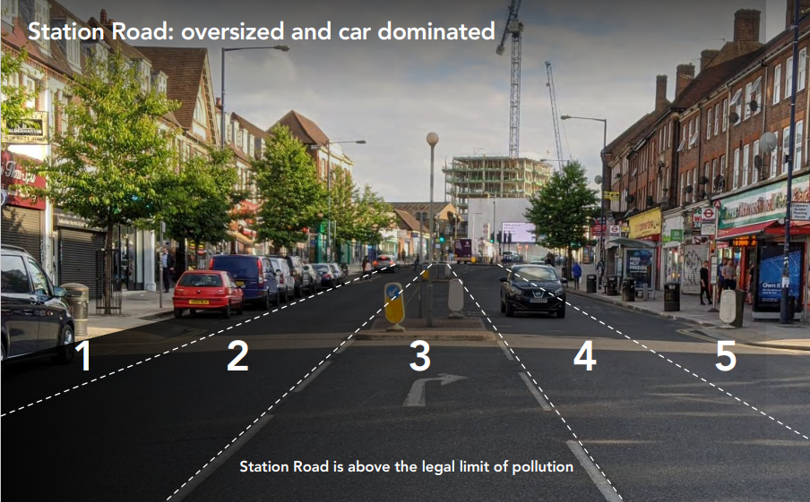
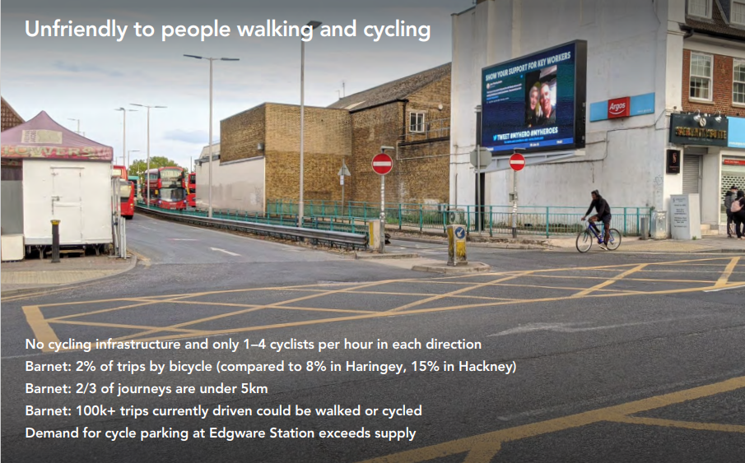
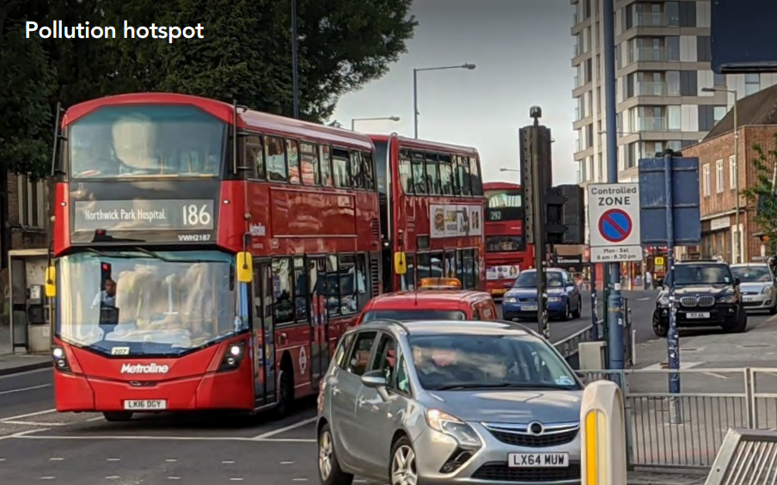

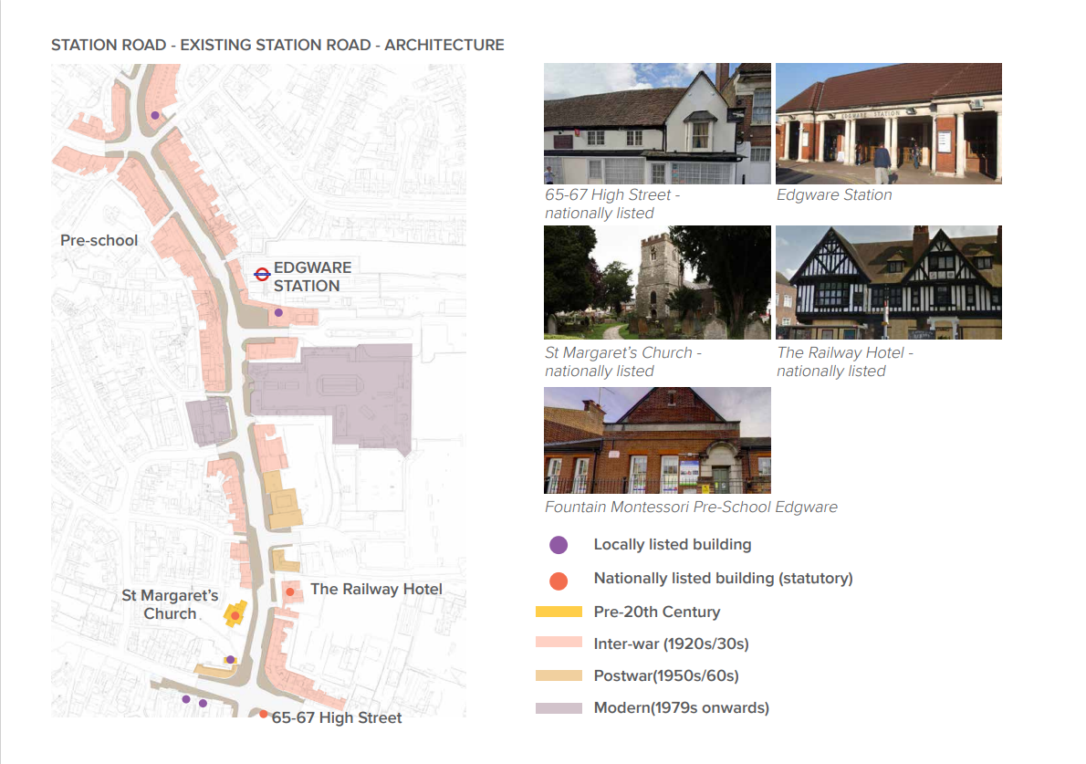
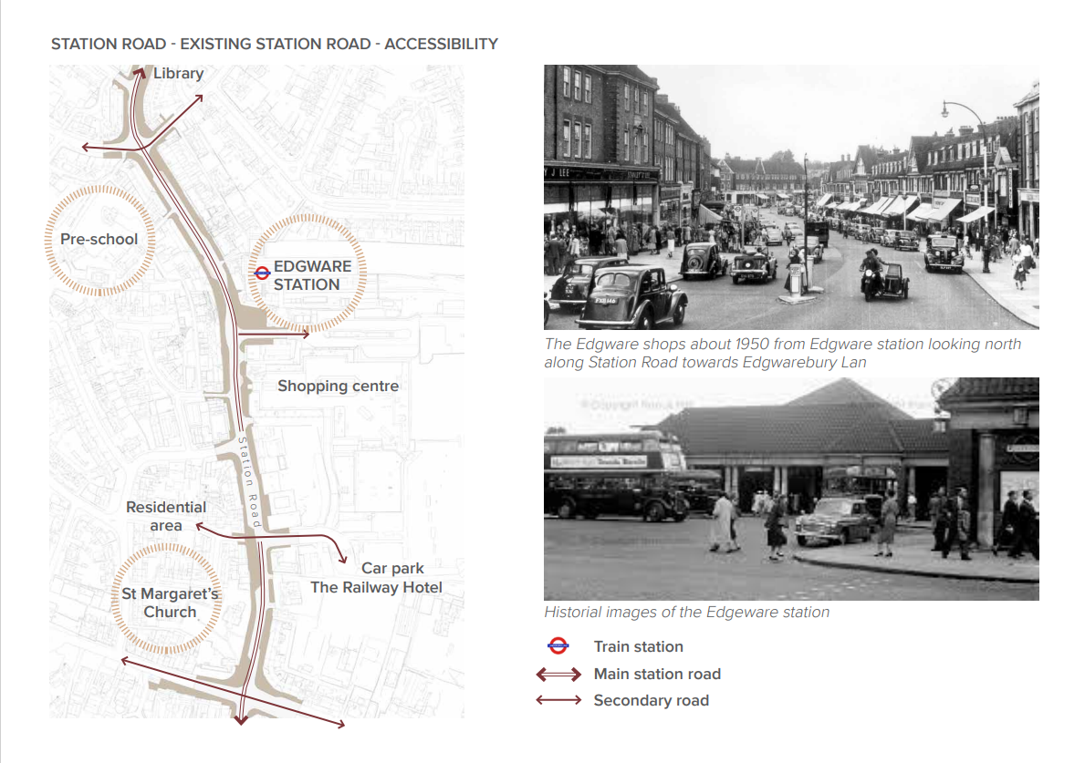
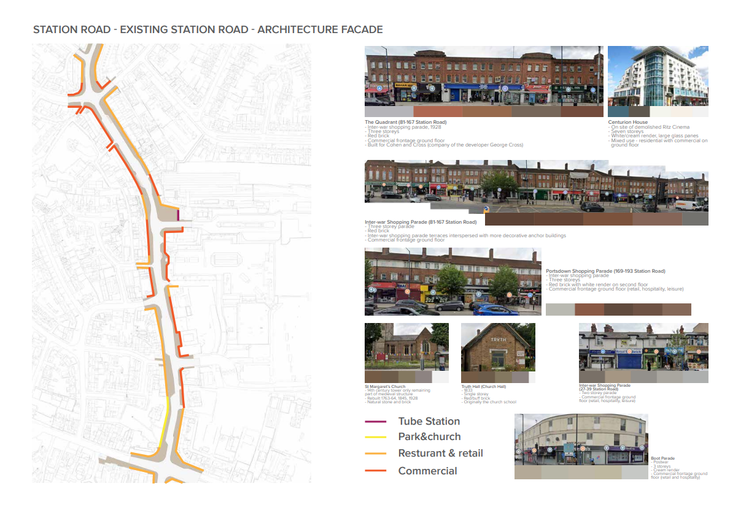

16
Contact

To submit your entry please go here.

For general enquires please contact: info@londonfestivalofarchitecture.org.

17
Disclaimer

The competition organisers are not liable for lost, misdirected, or late entries. Decisions of the jury represent their professional judgments and all decisions are final. While it is the intent to construct the winning scheme, the organisers reserve the right to not proceed with construction for any reason. Material submitted by you shall be your sole responsibility, shall not infringe or violate the rights of any other party or violate any laws, contribute to or encourage infringing or otherwise unlawful conduct, or otherwise be obscene, objectionable, or in poor taste. By submitting such material, you are representing that you are the owner of such material and/or have all necessary rights, licenses, and authorization to distribute it.

18
Commissioning organisations

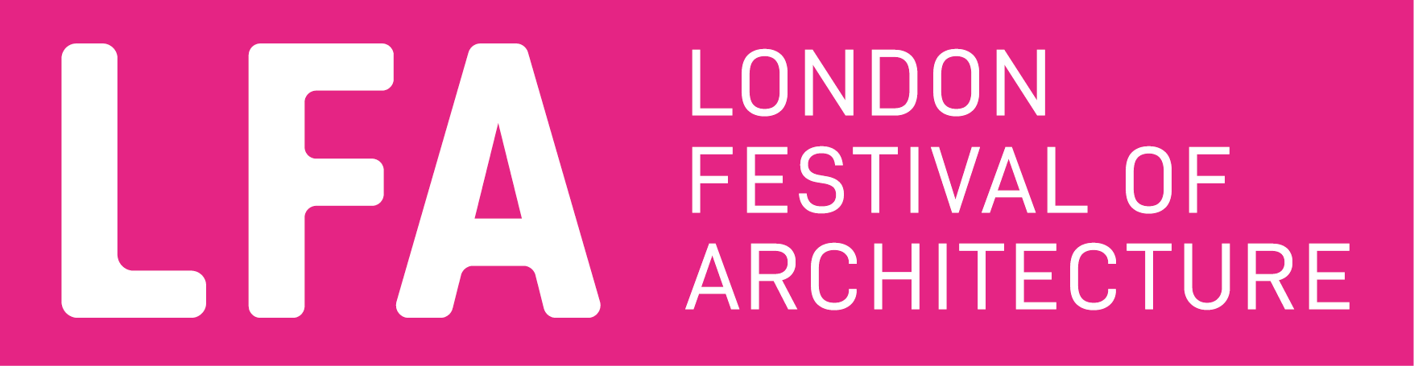

The London Festival of Architecture (LFA) is a month-long celebration of architecture and city-making, taking place every June across London. The Festival’s mission is to open up discussions around architecture, test new ideas and promote emerging talent. The Festival brings together the public and built environment professionals for the whole month of June and seeks to inspire and engage our audience with a programme that showcases London as a global architecture hub. LFA is run by New London Architecture (NLA), the world’s leading centre for the built environment industry.
www.londonfestivalofarchitecture.org
Twitter: @LFArchitecture
Instagram: @LondonFestivalofArchitecture

Ballymore is a developer with vast and varied experience, acknowledged as pioneers of some of Europe’s largest regeneration projects. Today, we remain owned and managed by the Mulryan family. Chairman and Group Chief Executive Sean Mulryan founded the business with his wife Bernardine Mulryan, in Ireland, in 1982.

We work in complex urban settings both new and old. In emerging markets, we create transformation and opportunity with ambitious mixed-use developments like Eurovea in Bratislava and we carry out sensitive modernisation in established and historic cityscapes like Old Spitalfields Market in the City of London.

Ballymore takes its responsibility as a place maker very seriously, putting quality of life and a connection to arts and culture at the core of our work. We developed a new headquarters for English National Ballet on London City Island, our ground-breaking project just south of Canary Wharf. We worked alongside the US government to move their embassy from Grosvenor Square to Embassy Gardens at Nine Elms, establishing a new riverside cultural district for the city and signalling a major shift in London’s diplomatic centre of gravity.

New Homes & Property Developer | Ballymore (ballymoregroup.com)
Instagram: @ballymore



Transport for London (TfL) is one of the largest landowners in London and as part of our long-term strategy, we are now taking forward development activity in a commercial property company that is wholly owned by TfL. TTL Properties (TTLP) – our wholly owned commercial property company – builds on the successful work that has already taken place in recent years, which is already helping to deliver thousands of new homes for the capital.
We have a diverse portfolio, including well-positioned assets across London, which comprises of 4.68m square feet of real estate, across retail, arches, commercial office, car parks and residential. A Purpose driven organisation, TTLP sets out to create well-designed thriving places, which creates a fund for future transport investment.

https://tfl.gov.uk/

From Edgware to Cricklewood, and Finchley to Hampstead Garden Suburb, Barnet is known for being one of London’s largest and greenest boroughs. Historically, Barnet has been a borough that has supported commerce with 30 town centres which play different roles in the wider community.

“We’re delighted that the borough of Barnet will be a feature destination in the 2023 London Festival of Architecture.”
“Barnet is home to many communities with distinct identities but which also have so much in common, and this reflects in our public realm. We’re a borough rich in historic buildings that have been at the centre of life in Barnet for generations. Today, we see Barnet growing and evolving to meet challenges and needs that our communities have in common, from quality housing to sustainable living.”
“Our architecture showcases how many cultures live alongside each other, sharing public spaces, amenities and buildings that together define the borough’s unique character. “
“Co-designing with our residents is integral to our approach to place-shaping. To ensure that we curate a programme that truly reflects our communities, we’ll consult our residents and ask them to choose the buildings they think should be part of the festival.”
Cllr Sara Conway, Chair of Barnet Council’s Community Leadership and Libraries Committee

