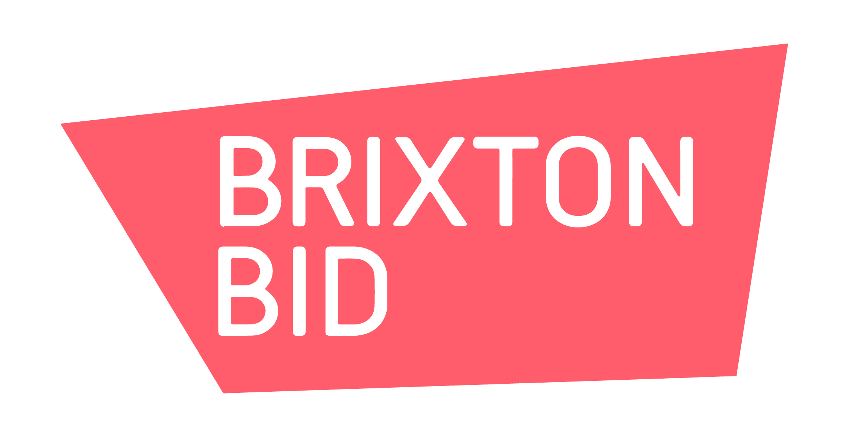



LFA Competition
Open Call – People at the Centre of Brixton

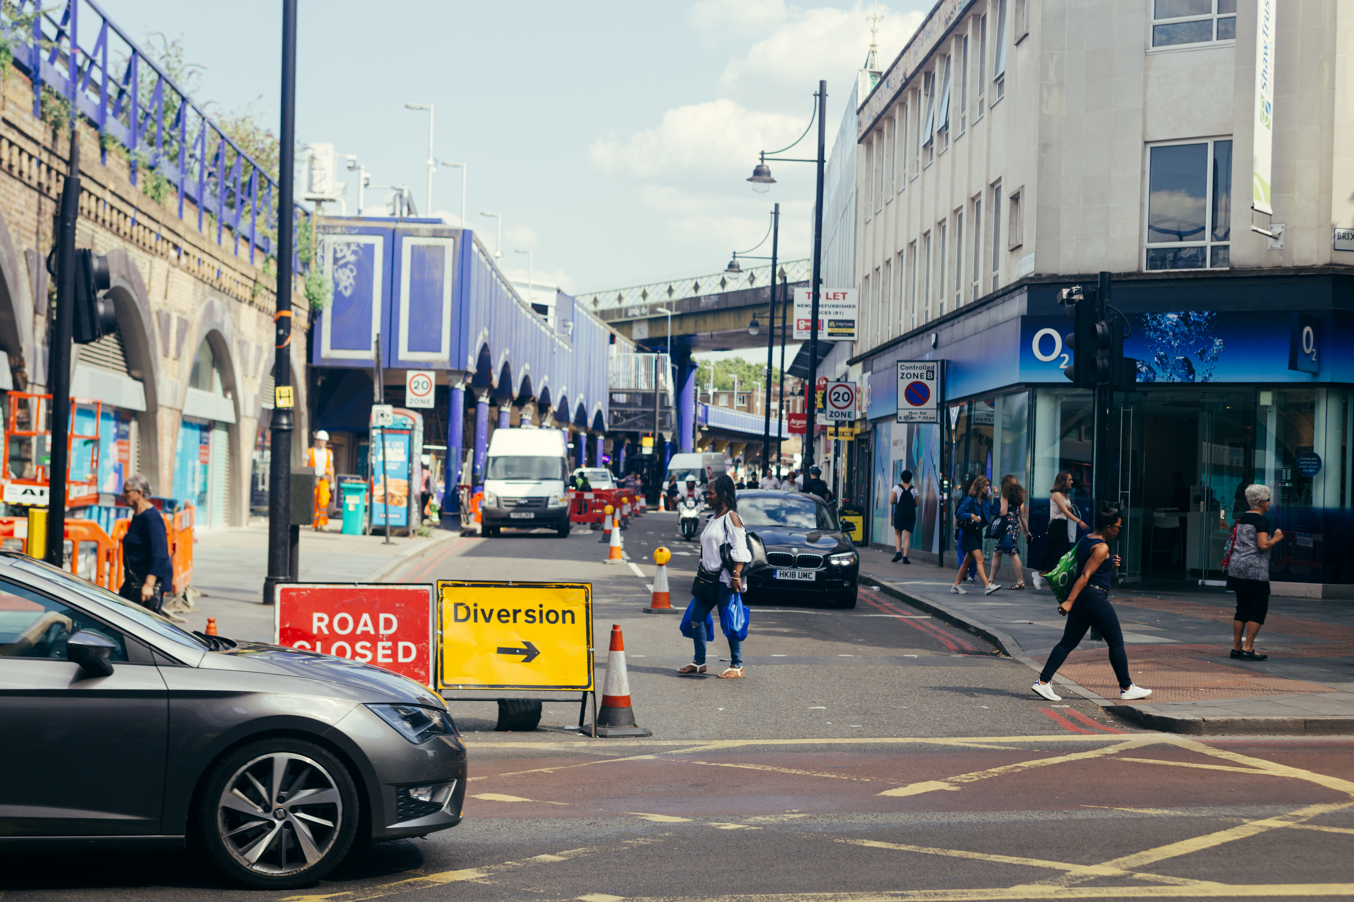

1
The commission
The London Festival of Architecture (LFA) has partnered with Lambeth Council and Brixton Business Improvement District (BID) on a design competition which invites architects, designers and artists to develop and submit a design proposal for a new public realm intervention that will act as a focal point for events and activities in Brixton during the LFA 2023.
At the heart of this competition is the desire to put people at the centre of the public realm in Brixton. This brief is asking applicants to design public realm interventions for two culturally significant sites in the centre of Brixton; Atlantic Road and Windrush Square, which can be activated during June by a series of community-led events. The design proposal should respond to this year’s LFA theme ‘In Common’, which aims to spark discussion and debate about the role that historical common land plays in our urban environment. At the same time ‘In Common’ looks forward, hoping to generate creative ideas fuelled by our collective desires for an equitable, equal and sustainable future.

This project is an opportunity to re-imagine these public spaces, to test alternative scenarios which improve the experience of residents, businesses and visitors to Brixton and create opportunities for people to dwell in non-transactional spaces.

A winning team will be confirmed in April and awarded £27,000 + VAT (which includes a £4,000 design fee) to develop a fully costed, feasible design that can be delivered in June and activated over the long weekend of 8th – 11th June.

2
Cultural Context

Brixton (originally Brixistane), a marshy wetland named after a Saxon meeting stone that brought communities together, has become a global shorthand as a home of diversity, culture and creativity. From agricultural land and the home of Brixton Windmill (London’s last working windmill), the railway brought with it developments which included Electric Avenue, the first shopping street to be lit by electric lighting in 1880. Victorian Brixton became a home for theatre, including Brixton Theatre, The Empress, The Scala and Pallidum Theatres: this legacy is brought back to the newly opened Brixton House Theatre.

A famous shopping destination, Brixton's Bon Marche was the first purpose-built department store in the country built in 1876 by a local businessman whose racehorse Roseberry won an unconceivable double at Newmarket. Morley's department store opened four years later, followed by the bustling street markets and covered Brixton Village and Market Row which continue to chart the changing residents, filled with shoppers in search of goods from Caribbean plantain to South American papaya.

Brixton is seen as the spiritual home of the Windrush Generation, with many Caribbean immigrants arriving from 1948 choosing to settle in the residential terraces due to the proximity to the temporary housing in the Deep Shelters at Clapham South and the local Job Exchange formerly on Coldharbour Lane.

Brixton's streets became spaces of uprising in 1981, where the Black community rose up against racial discrimination and police brutality. Brixton today is underpinned by inclusivity, diversity, equality, and justice, that are embedded, shared and celebrated every day. In 2021, Brixton BID twinned with Harlem’s 125th Street BID (NYC) to celebrate the common threads between these two radical communities.

Continuing to put people at the centre of place, Brixton is at the heart of projects that look to reimagine the public realm. Lambeth Council's pledge to be net zero by 2023 starts a journey towards new innovative solutions to modern life, and the Brixton Creative Enterprise Zone is exploring how the public realm can facilitate creative uses. While the BID's Reimagining Atlantic Road project seeks to solve the challenges of this busy artery through central Brixton with innovative solutions that design users into the street scape and the new wayfinding strategy X marks the spot. June 2023 will see the commemoration of Windrush 75 with plans for community celebration through the borough, taking to the streets with spectacular displays of ancestry, island life, carnival arts and dreams of the future.

3
Site Context
There are two sites to be considered for this design competition: Windrush Square and Atlantic Road. The competition is keen to arrive at an intervention(s) that can work for both locations. There are multiple possible locations for where the intervention(s) could be situated in the Square and along Atlantic Road, which are open for applicants to review and suggest at Stage 2 of the competition.
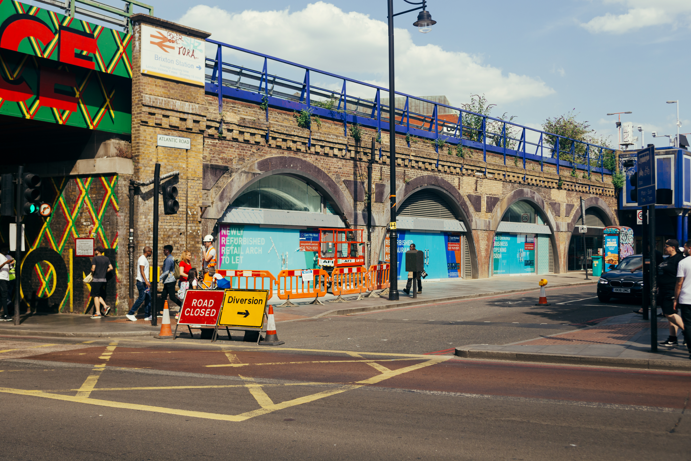
Atlantic Road
Atlantic Road is the ‘spine’ of Brixton town centre. With a rich history, home of many traditional businesses, intertwined with Brixton Village, Electric Avenue, Electric Lane, Popes Road, the Arches, Brixton Rail Station, Coldharbour Lane and Brixton Road, it is full of challenges and opportunities.
It is currently sandwiched by two Low Traffic Neighbourhoods (LTNs) namely Railton Road LTN and Ferndale Road LTN, the road is full of day time and night time businesses with their operations having a major impact on how the street is used, day and night. There may be the possibility of parking bays being suspended on Atlantic Road on a temporary basis for this intervention as well as potential weekend road closures.
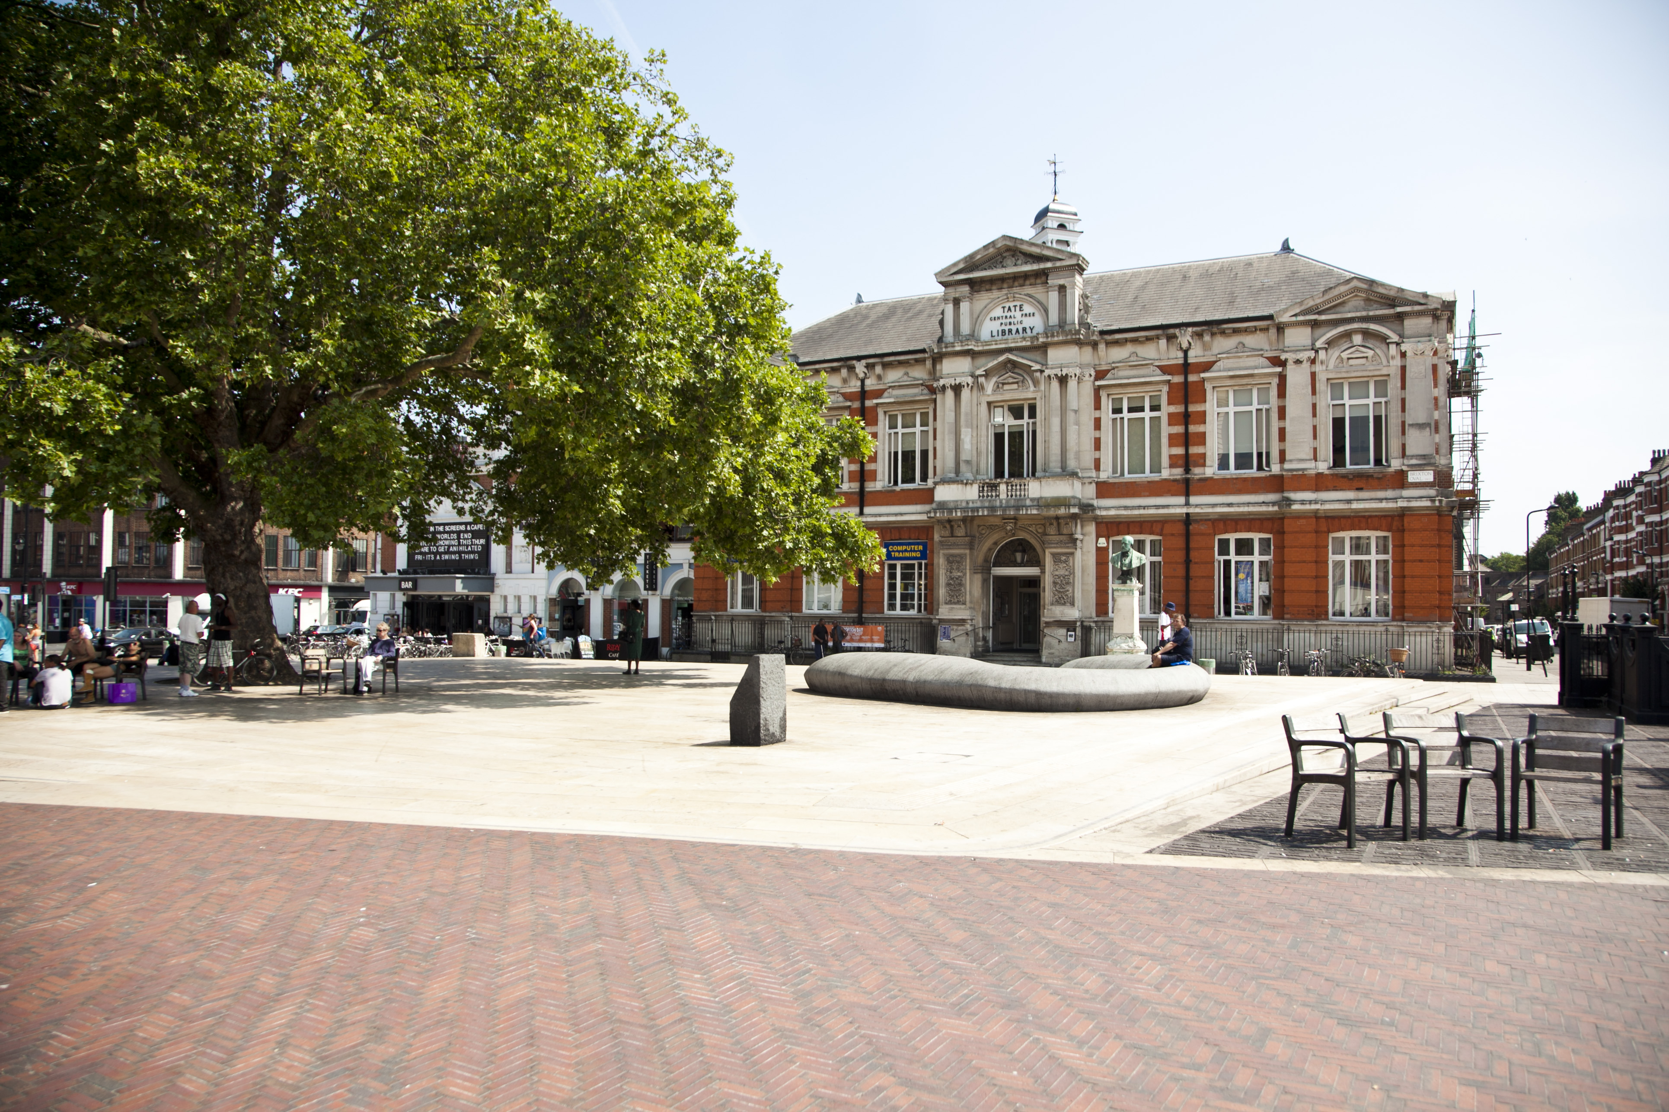
Windrush Square
Windrush Square is an open public space in central Brixton, re-named 50 years after the arrival of HMT Empire Windrush to recognise the contribution of the African Caribbean community to the area which housed the first large group of post-war West Indian migrants. Situated on the site of historical common land in Lambeth, Windrush Square is an urban common, the land having been protected from development in 1806 by the Rush Common Act.
This year’s LFA theme ‘In Common’ aims to spark discussion and debate about the role which historical common land plays in our urban environment. We see potential in the exploration of the historical roots of this theme (as well as the broader definitions) in this project for rethinking how we design and develop public spaces for the existing and future generations.
It is also notable that three cultural spaces (The Ritzy, Brixton Library, and Black Cultural Archives) face onto Windrush Square, and we see greater potential for Windrush Square to be more frequently activated on an ongoing basis for events and cultural expression.
More detailed information on both sites will be shared with shortlisted applicants, once selected, who will be invited to attend a site visit.
4
Design Requirement
The applicant should provide a creative design solution for site-specific public realm intervention(s) that acts as a catalyst and focal point for people to come together and from which events and activities can take place during the LFA and beyond.
The design should creatively respond to this year’s LFA theme ‘In Common’.
The key objectives of the project are to deliver a design that:

- Improves the experience of public space for residents, local employees, businesses and visitors alike
- Celebrates the culture, character and creativity of Brixton
- Create opportunities for people to dwell in non-transactional space, come together and spark conversation
- Creates a connection (in some way) between Atlantic Road and Windrush Square
- Provides a vehicle for activation by a programme of activity during LFA 2023
- Is robust enough to remain in situ outdoors for up to 28 days
- Can be sustainably produced

Further guidance:

- The design proposals need to foster participation and respond to the local context
- The project will be in situ for up to 28 days and you should consider the longevity and appearance of your design accordingly, to ensure that no or minimal maintenance is required during this period.
- Applicants are asked to consider the afterlife of the installation post-festival when designing (re-homing, re-using, recycling).
- There will be some additional budget available for local groups to access for activating the installation during June.

5
Budget

The total budget available for delivery of this project is circa £27,000 + VAT, including the cost of implementation - materials and any necessary licenses or other capital costs.

The winning team will be responsible for leading on the fabrication and installation of the design, whilst working closely with Lambeth and the Brixton BID teams to facilitate the installation.

The £27,000 budget outlined includes a maximum £4,000 designer fee to cover on-going design fees and other costs required to deliver the concept.

The winning team will be expected to undertake the following tasks:

- To develop a fully costed, feasible design that can be installed in June 2023 in the two locations
- Project management of the installation of winning design

6
Submissions requirements

This competition has a two stages submission.

This first stage submission should include:
- Full name and contact details including postal address, contact number and email of project lead.
- Brief biographies of all the project team.
- A 200-word description about your practice along with any relevant technical experience acquired through previous projects.
- A selection of relevant previous work, including images.
- A short paragraph of max. 300 words on why you are interested in being involved in the project, your connection to Brixton and, how are you going to work with the local community to deliver your proposal if selected. Please include thoughts about your vision including any initial written reactions you may have to the brief.
- No design work is required for the first stage.

These submissions will be shortlisted by the judging panel. Up to six shortlisted practices will then be invited to develop a design concept based on the information laid out in this open call and will be awarded an honorarium of £500 + VAT each. The work required for the second phase of the project will be reflective of the honorarium sum.

At shortlisting, the second stage submission should include:
- 2 x A2 boards in portrait format explaining your proposal.
- PowerPoint presentation for the purposes of judging.
- The submission should but is not limited to including hand or computer drawn 3D design visualisation, key construction details drawn to scale, with key dimensions noted, an outline all materials, budget, maintenance plan and fabrication process.

Submission information
For any questions about the competition or submission process, please email: info@londonfestivalofarchitecture.org

7
Eligibility

The competition is open to architects, landscape architects, designers and artists. We welcome collaborations; however, the project team must include a qualified architect or landscape architect.

The judges encourage entries from, or collaborations with groups who are underrepresented in architecture and design. The focus is on inclusivity, cross-collaboration and practices with innovative approach. The judges will give priority to submissions from local designers or those who have chosen to collaborate with local groups.

8
Deadline and submission details

- Deadline for first submission is Midday, 2nd March. Submissions received after time this will not be considered.
- For competition enquires please contact: info@londonfestivalofarchitecture.org
- To send your expression of interest in a PDF format go here.
- The PDF should be no more than 5MB and 10 A4 pages.
- You will receive an email confirming the receipt of your submission.

9
Schedule outline

Submissions open: 9 February
Submissions closed: 2nd March (midday)
Successful shortlisted teams notified: w/c 6th March
Site visit with shortlisted teams: w/c 13th March
Round 2 submission deadline: 29th March
Final judging / interviews: TBC
Winner notified: w/c 3 April

10
Judging panel

The judging panel will include:

Rosa Rogina, London Festival of Architecture, Director (Chair)
Gianluca Rizzo, Brixton BID Director
Binki Taylor, LFA Curation Panel 2023, The Brixton Project
Lambeth Council Representative
Tim Gledstone, Partner at Squires & Partners
Jessica Dyer, Brixton BID / The Brixton Project
Young people’s representative

With more judges to be announced shortly.

11
Judging criteria

Round 1 Judging Criteria
- Practice/Team profile - 40% Does the team have skilled professionals for delivering the proposal in line with eligibility outlined in the Open Call? Does the team have a diverse set of skills and experience? Are the previous work experiences and/or their work methodologies and wider design aspirations relevant to the competition?
- Initial vision - 30%: Does the proposal's initial written reflection to the brief suggest innovation, surprise and creativity? Does it explore a new and original way to use and engage with the area?
- Feasibility - 30%: Does it propose an approach which seems feasible and deliverable within the budget and set timeframe?

Round 2 Judging Criteria
- Overall design – 25%
- Contextual design and approach to public engagement – 20%
- Costs – 20%
- Approach to environment and sustainability – 20%
- Longevity and implications for maintenance – 15%

12
Further information

- Submissions will be judged on originality, demonstration of creativity, relevance to the brief, in-depth understanding of the Brixton cultural context, as well as feasibility and how the proposal works in the context of the site.
- To process entries to this competition we will share your application and any associated personal data provided on the application with our jury and competition partners.
- All applicants will be notified of the outcome of their application, but due to the volume of submissions we may not be able to provide feedback to entrants individually.
- The ownership of Copyright of the design will be in accordance with the Copyright, Designs and Patents Act 1988, that is Copyright rests with the author of the submitted design.
- All designs remain the intellectual property of the designer however the winning design will itself when built will be the property of the landowners.
- Please bear in mind the project requires a fast turn around and may have peak moments when your practice will need to dedicate sufficient staff to deliver the project on time, to budget and to the high standard expected by all stakeholders.
- If your practice/collaboration is appointed to deliver the project it will need to have the following insurance: Employers Liability, Professional Indemnity, Public Liability.
- Significant efforts are made by all stakeholders of the project to ensure wide media coverage.
- LFA reserve the right to use images from the submissions for promotional purposes in press, social media and publications. All endeavours will be made to ensure accurate accreditation.

13
Useful links

London Festival of Architecture:
www.londonfestivalofarchitecture.org

LFA Theme ‘In Common’
https://www.londonfestivalofarchitecture.org/media-item/in-common-reflections-from-the-curation-panel/

Lambeth Kerbside Strategy – launched January 2023
https://moderngov.lambeth.gov.uk/documents/s142785/Appendix%20A%20-%20Lambeths%20Kerbside%20Strategy.pdf

14
Contact

To submit your entry please go here.

For general enquires please contact: info@londonfestivalofarchitecture.org

15
Disclaimer

The competition organisers are not liable for lost, misdirected, or late entries. Decisions of the jury represent their professional judgments and all decisions are final. While it is the intent to construct the winning scheme, the organisers reserve the right to not proceed with construction for any reason. Material submitted by you shall be your sole responsibility, shall not infringe or violate the rights of any other party or violate any laws, contribute to or encourage infringing or otherwise unlawful conduct, or otherwise be obscene, objectionable, or in poor taste. By submitting such material, you are representing that you are the owner of such material and/or have all necessary rights, licenses, and authorization to distribute it.

16
Commissioning organisations



The London Festival of Architecture (LFA) is the world’s largest annual architecture festival and will be exploring the theme of ‘act’ in 2022. The LFA is part of New London Architecture (NLA), and has a mission is to support London’s architectural and design talent, enthuse and engage with the public, and find new ways to look at familiar places. In 2021 the LFA explored the theme of care, and celebrated innovation and design through a hybrid programme of activity last June. A year-round programme of design competitions, design charrettes, campaigns and other activities also champions London as the best place in the world to practice and enjoy architecture.
www.londonfestivalofarchitecture.org
Twitter: @LFArchitecture
Instagram: @LondonFestivalofArchitecture

The London Borough of Lambeth is home to many diverse communities. We provide services such as planning, social work, housing and schools to 303,000 residents and hundreds of businesses. Lambeth includes the world class cultural hub of the South Bank, the bustling street markets of Brixton, the open spaces of Clapham and Streatham Commons and dynamic neighbourhoods including Vauxhall, West Norwood and Stockwell. The borough is rich in history and is very well connected, close to central London and the City. Everything we do as a council is guided by our values, and we are always on the look out for people who are as committed to these principles as we are: Fairness: ensuring all our staff and customers are treated equally. Respect: consulting our communities, valuing our staff and treating everyone with courtesy. Excellence: attaining high standards for all customers and recognising staff who provide excellent service. Service: ensuring that customers receive the services they want and need. Honesty: being open with all staff and customers and fighting fraud, dishonestly and discrimination.

www.lambeth.gov.uk/

The Brixton Business Improvement District (BID) is a not-for-profit organisation representing over 550 organisations, Funded and led by the local business community, Brixton BID delivers a variety of initiatives, projects and events to make Brixton a better place day and night. The Brixton BID works to make the district a sustainable and distinctive destination. It provides additional opportunities for local organisations whilst creating an attractive environment for all. When Brixton works together, everything is possible.

brixtonbid.co.uk/

